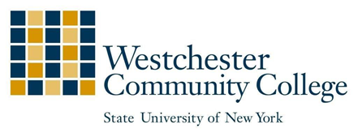
Financial Aid Office Phone 914-606-6773
75 Grasslands Road Fax 914-606-7807
Valhalla, NY 10595 Finaid@sunywcc.edu

Summer 2018 Financial Aid Application

If you want to be considered for summer financial aid, you must:
- Be currently enrolled in a degree-granting program at WCC and enrolling in at least 6 credits that work toward your degree
- Be making Satisfactory Academic Progress (SAP)
- Apply before the Summer Financial Aid Application deadline of May 1, 2018
- Pay any outstanding balance to the College
- Complete the 2018-19 FAFSA at www.fafsa.gov and the NYS Tap Application at www.tapweb.org. by May 1, 2018
- Complete, sign and submit to the Student Financial Assistance Office, Administration bldg., room 120 or fax to (914) 606-7807 or email to finaid@sunywcc.edu

Student’s Last Name First Name MI Student Identification Number

___________________

Student’s Address While at College City State Zip

Student’s Permanent Address City State Zip

1. My summer phone number is

2. I plan to take

credits during the 2018 summer semester.
Student Signature: Date:

Please note: We must evaluate your SAP before and after the summer term regardless of the number of credits attempted. If you received a failing grade or withdraw from a course, you should contact the Financial Aid office to discuss how a summer course will impact your aid eligibility for Fall 18.

