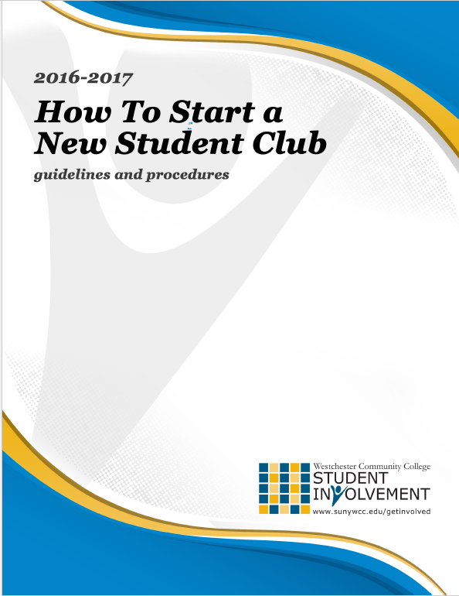

PROCEDURE FOR APPROVING A NEW STUDENT CLUB

CLUB DEFINITION

A STUDENT CLUB is a student-run group of like-minded students who have gathered together to explore, celebrate and share-in a common purpose. They have created a formal operating charter with a unique mission and received formal approval from the Student Government Association. Clubs receive support from members of the faculty, staff, or administration who serve as club advisors.

REQUIRED DOCUMENTATION

- Students wishing to start a new club should first review the current listings of recognized clubs found at www.sunywcc.edu/clubs.

- If there is no similar club, students should recruit a member of the college faculty, staff, or administration to serve as the Advisor to their group. For more information as to the role of a club advisor, please refer to the Club/Organization Policy & Procedures found at www.sunywcc.edu/clubs.

- Students will also have to complete the following documents:

  - Request for Recognition Form. This is an intake form describing the basics of the proposed group. It can be found on page three (3) of this packet.

  - List of Interested Students Form. This is a listing of students who have expressed interest in joining the club if it receives approval. A minimum of fifteen (15) interested students is required. It can be found on page four (4) of this packet.

  - Constitution. A constitution is the operating charter for the club. The draft template that must be used can be found on page six (6) with directions on page five (5) of this packet. Constitutions must be typed and E-MAILED to the Department of Student Involvement at getinvolved@sunywcc.edu.

- After a club completes the requirements listed above, they must submit all the completed documents to the Department of Student Involvement (Student Center Room 108) for processing and next steps.

If you have questions or need help during this process, you can make an appointment with a member of the Student Involvement staff by calling 914-606-6731, emailing getinvolved@sunywcc.edu, or visiting Student Center Room 108.
PROCEDURE FOR STUDENT GOVERNMENT RECOGNITION

- Once verified that all information is completed, The Department of Student Involvement will notify the Student Government Association (SGA) that a proposal for a new club has been submitted.

- The documents will be sent to the SGA Secretary who will assign a member of the SGA Constitution Committee to review the packet. The SGA Constitution Committee may request to meet with the students who are making the new club proposal to ask questions and suggest changes to the proposed club’s constitution or other documents. After being reviewed by the SGA Constitution Committee, the students proposing the new club will be notified by the SGA Secretary that their packet will be sent to the SGA Senate for review.

- The SGA President will notify the club of the date that their new club is scheduled for their presentation to the SGA Senate. This presentation should include: (1) an overview of the club’s mission; (2) the name and background of the faculty advisor; (3) anticipated events or initiatives the club will sponsor; (4) reasons why the club is needed on campus; and (5) other criteria considered important by the students proposing the club.

- The SGA Senate reviews new club proposals once a semester. The following dates are scheduled for this academic year:

Semester | Deadline to Submit Proposal | Senate Presentation Date
Fall 2016 | Monday, November 21  3:00pm | Thursday, December 1  4:00pm
Spring 2017 | Monday, April 11  3:00pm | Thursday, April 20  4:00pm

- If approved by the SGA Senate, the club shall be officially recognized by the College and will be entitled to all rights and benefits associated with club recognition. The club may apply for funding from the Student Government Association the semester after it receives approval.

NEW CLUB/ORGANIZATION
Request for Recognition Form
Club/Organization Name:
Student Presenting Request:
Student Email:
Perspective Club Advisor/Department:
Title of Advisor:
GENERAL INFORMATION
What is the purpose and mission of your club/organization?
What sort of opportunities and/or activities will your club/organization sponsor for the campus community?
Why should your club/organization be recognized on campus?
Agreement & Verification
I have read, understood and feel I am able to complete the responsibilities and requirements of starting a recognized club/organization at Westchester Community College. I affirm that the information which I have provided on this form and all other materials for recognition are complete, accurate, and true to the best of my knowledge.
Student Presenting Request
Student Presenting Request
Name (Printed)
Signature |  |  | Date:
Prospective Club Advisor
Name (Printed)
Signature |  |  | Date:

NEW CLUB/ORGANIZATION
LIST OF INTERESTED STUDENTS
By signing below, I am indicating my interest in joining and being active in the newly proposed club, called _____________________________________________________________ while I continue as a student at Westchester Community College.

Name (Printed) |  | Signature | Student ID
1
2
3
4
5
6
7
8
9
10
11
12
13
14
15
16
17
18
19
20
21
22
23
24
25
26
27
28
29
30
***If you have additional names, please just duplicate this page***

NEW CLUB CONSTITUTION
TEMPLATE & INSTRUCTIONS

- The following template MUST be used when writing your prospective club constitution.

- Anything that is BOLD, UNDERLINED, & ITALICIZED means you must fill in the missing information. Simply write over those words and write in the information it calls for.

- You should make sure everything is written in complete sentences.

- All constitutions must be typed and E-MAILED to the Department of Student Involvement at getinvolved@sunywcc.edu.

- If you have questions or need help when writing your constitution, you can make an appointment with a member of the Student Involvement staff by calling 914-606-6731, emailing getinvolved@sunywcc.edu, or visiting Student Center Room 108.

NAME OF CLUB

WESTCHESTER COMMUNITY COLLEGE

ARTICLE I: NAME

The name of this club/organization shall be NAME OF CLUB.

ARTICLE II: PURPOSE

- The mission of the NAME OF CLUB is to:

  - FIRST STATEMENT OF PURPOSE

  - SECOND STATEMENT OF PURPOSE

  - THIRD STATEMENT OF PURPOSE (if needed)

  - FOURTH STATEMENT OF PURPOSE (if needed)

ARTICLE III: MEMBERSHIP

- NAME OF CLUB shall not discriminate against any student on any basis, including, but not limited to: real or perceived age, race, sex, gender identity/expression, sexual orientation, sexual history, religious orientation, physical or mental disability, veteran status, alienage, citizenship, marital or parental status, legally recognized domestic partnership status, national origin, ancestry, creed, political belief, arrest and/or conviction record, or any other criterion prohibited by federal, state or local law.

- Any student attending Westchester Community College who has paid the student activity fee is eligible to be a member of NAME OF CLUB.

- Students can become a member of NAME OF CLUB by STATE HOW A STUDENT BECOMES A MEMBER OF YOUR CLUB.

- Members of NAME OF CLUB are expected to STATE WHAT EXPECTATIONS YOU HAVE OF YOUR MEMBERS (i.e. attend meetings, help at events, etc).

- Members can be removed from the NAME OF CLUB for STATE WHY A STUDENT CAN BE REMOVED AS A MEMBER OF YOUR CLUB by STATE HOW A STUDENT CAN BE REMOVED AS A MEMBER OF YOUR CLUB.

ARE THERE OTHER ITEMS YOU WANT TO ADD TO MEMBERSHIP?

ARTICLE IV: OFFICERS

- NAME OF CLUB shall have NUMBER officers.

- All officers must attend all trainings sponsored by the Department of Student Involvement.

- All officers must be members of the NAME OF CLUB.

- The following officer positions are established for NAME OF CLUB:

PRESIDENT

    - The President shall preside over all meetings of the NAME OF CLUB.

    - The President shall ensure that the mission and purpose of NAME OF CLUB are upheld.

    - The President shall ensure all responsibilities of the club as detailed by the Office of Student Involvement and the Student Government Association are completed on time.

OTHER RESPONSIBILITIES?

  - VICE PRESIDENT

    - The Vice President shall assist the President in their duties and assume all the duties and responsibilities of the President in his/her absence.

OTHER RESPONSIBILITIES?

  - TREASURER

    - The Treasurer shall be responsible for keeping track of all monies and funds of NAME OF CLUB.

    - The Treasurer shall understand and adhere to all the financial policies and procedures of the Department of Student Involvement, Faculty/Student Association and the Student Government Association.

OTHER RESPONSIBILITIES?

  - SECRETARY

    - The Secretary shall manage all club/organization documents and correspondence.

    - The Secretary shall keep accurate records and notes of all meetings.

OTHER RESPONSIBILITIES?

  - CLUB COUNCIL REPRESENTATIVE

    - Shall attend every meeting of the Student Government Association Club Council.

    - Shall represent the interests of club/organization to the Club Council.

    - OTHER RESPONSIBILITIES?

  - OTHER OFFICER POSITIONS

    - IF SO, WHAT ARE THEIR RESPONSIBILITIES?

  - ADVISOR

    - The divisor shall serve in a non-voting capacity and provide guidance to the club/organization.

    - The Advisor shall be a member of the College faculty, staff or administration.

    - The Advisor will attend meetings of the club/organization and provide advice and recommendations for club action.

    - The Advisor shall attend trainings sponsored by the Department of Student Involvement.

    - The Advisor is selected by STATE HOW THE ADVISOR IS SELECTED.

    - The Advisor can be removed by STATE HOW AN ADVISOR CAN BE REMOVED.

- The above will comprise the Executive Committee of a club/organization.

- The Officer can serve a maximum of NUMBER semesters in their position.

- The Officers are selected by STATE HOW AND WHEN THE OFFICERS ARE SELECTED OR ELECTED (i.e. a vote of the club membership)

- The term of Officers shall be STATE HOW LONG AN OFFICER SERVES IN THEIR TERM (i.e. a semester, the full academic year)

- An Officer can be removed from his or her position for STATE WHY AN OFFICER CAN BE REMOVED FROM HIS/HER POSITION by STATE HOW AN OFFICER CAN BE REMOVED FROM HIS/HER POSITION

ARE THERE OTHER ITEMS YOU WANT TO ADD TO OFFICERS?

ARTICLE V: MEETINGS

- The NAME OF CLUB will meet STATE HOW OFTEN THE CLUB WILL MEET.

- The NAME OF CLUB will need STATE HOW MANY MEMBERS MUST BE PRESENT for an official meeting to occur.

ARE THERE OTHER ITEMS YOU WANT TO ADD TO MEETINGS?

ARTICLE VI: VOTING

- Members of NAME OF CLUB will be eligible to vote in club business.

- Traditional club business will be conducted by STATE BY WHICH METHOD VOTES ARE HELD (secret ballot, voice vote).

- Votes will be approved by a STATE WHAT OUTCOME IS NEEDED TO PASS A VOTE (majority, plurality, other).

- The Elections of officers will be decided by STATE HOW AND WHEN THE OFFICERS ARE SELECTED OR ELECTED (i.e. a vote of the club membership).

ARE THERE OTHER ITEMS YOU WANT TO ADD TO VOTING?

ARTICLE VII: CLUB RESPONSIBILITIES

- NAME OF CLUB shall abide by the policies, procedures, and requirements established by the Student Government Association, Faculty/Student Association and Westchester Community College.

- NAME OF CLUB shall register the club at the beginning of each semester with the Department of Student Involvement.

- NAME OF CLUB shall send a representative to every meeting of the Student Government Association Club Council.

ARTICLE VIII: AMENDMENTS & DISSOLUTION
OF THE ORGANIZATION

- All amendments to this constitution must be passed by a Majority, 3/4 Majority, ETC? vote of the total club membership.
- Constitution updates must be submitted to the Student Government Association Senate for review and approval before they are deemed official.

- NAME OF CLUB must email any and all updates or changes to its constitution to the Department of Student Involvement after they have received approval by the Student Government Senate.

- In the event of the dissolution of this club, all accrued funds and assets revert back to the Student Government Association.

