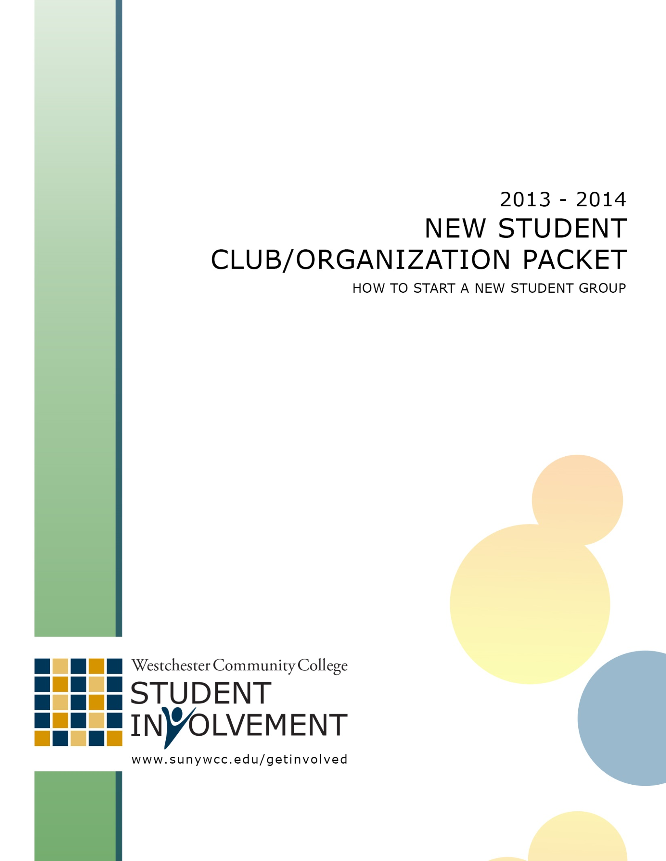

Procedure for
Approving a New
Club/Organization

Research & Preparation
- Students wishing to start a new club/organization should first review the current listings of recognized clubs/organizations on campus. Students should ensure that there is not already a group on campus with a similar mission to the club/organization they wish to start.

- If there is no similar club/organization, students must complete and have signed the Request for Recognition Form, found on page 2 of this packet.

- Students must recruit a member of the College faculty, staff, or administration to serve as an Advisor to their group. For more information as to the role a club/organization Advisor has, please refer to the Club/Organization Policy & Procedures Manual found at www.sunywcc.edu/clubs.
NOTE: For curriculum based groups, the Advisor should be a Professor or Administrator in the curriculum the group is based on.

- Students will have to recruit a minimum of fifteen (15) students who want to join their prospective club/organization. These students will have to sign the List of Interested Students form included in this packet.

- Students will have to draft a Constitution for their club/organization. This will serve as the operating charter for their club/organization, should they be recognized.

Students MUST use the Constitution Template
when writing their Constitution
(found on page 5)

- After a club/organization completes the requirements listed above, they must submit all the documents to the Office of Student Involvement (Student Center Room 103).

- The Student Government Association (SGA) will be notified that a proposal for a new club/organization has been submitted. Using policies and procedures that incorporate the spirit of equal access and opportunity, the SGA may recognize and incorporate clubs/organizations into their Association.

Procedure for Student Government Recognition
- Once all forms and initial requirements have been met, submitted and filed with the Office of Student Involvement, the Student Government Association (SGA) President will be notified.

- The documents will be sent to the President, who will forward a copy of the packet of information to the SGA Constitution Committee for review.

- The SGA Constitution Committee will review the packet. This Committee may request to meet with the students to ask questions and suggest changes/amendments to their submitted new club constitution.

- After being reviewed by the SGA Constitution Committee, the students will be notified that their proposed club will be sent to the SGA Senate for review. The student(s) who submitted the request will be required to make a formal presentation before the SGA Senate. This presentation should include: (1) an overview of the club/organization, (2) its goals/objectives, (3) the name and background of the faculty advisor; (4) reasons why the club is needed on campus and (5) other criteria considered important by the presenting students.

- The SGA Senate reviews constitutions typically once a semester, toward the end of each term.

- If approved by the SGA Senate, the club/organization shall be officially recognized and be entitled to all rights and benefits associated with club/organization recognition.

New Club/Organization
Request for Recognition
Form

Name of Club/Organization:

Student Presenting Request:

Student Email:

Perspective Club Advisor:

Title of Advisor:

GENERAL INFORMATION
- What is the purpose and mission of your club/organization?

- What sort of opportunities and/or activities will your club/organization sponsor for the campus community?

- Why should your club/organization be recognized on campus?

Agreement & Verification

I have read, understood and feel I am able to complete the responsibilities and requirements of starting a recognized club/organization at Westchester Community College. I affirm that the information which I have provided on this form and all other materials for recognition are complete, accurate, and true to the best of my knowledge.

Student Presenting Request:

__________________________ ______________
Name (Printed) Signature Date

Perspective Club Advisor:

__________________________ ______________
Name (Printed Signature Date

New Club/Organization
List of Interested Students

Name of Club/Organization:

Student Presenting Request:

Student Email:

Perspective Club Advisor:

Title of Advisor:

By signing below, I am indicating my interest in joining and being active in the newly proposed club/organization listed above while a student at Westchester Community College.

Name (Printed) | Signature | Date
***If you have additional names, please just duplicate this page***
New Club/Organization
Sample Constitution

Students looking to have a new club/organization approved at Westchester Community College will have to draft a Constitution for their club/organization. This will serve as the operating charter for their club/organization, should they be recognized. This is the most critical part of any group looking for recognition. This document will be subject to the most amount of scrutiny by the Student Government Association, so it is important that all directions are followed.

DIRECTIONS FOR WRITING YOUR CONSTITTUION:

- The template on the following pages MUST be used when writing your prospective club/organization’s Constitution.

- Anything that is BOLD, UNDERLINED, & ITALICIZED means you must fill in the missing information. Simply click on the grey text box and write directly over it.

- You should make sure everything is written in complete sentences.

- All Constitutions must be typed and submitted to the Office of Student Involved (STC 103) at the same time as the other recognition documents.

NAME OF CLUB/ORGANIZATION
Westchester Community College

Article I: NAME
The name of this club/organization shall be, NAME OF CLUB/ORG.

Article II: PURPOSE
- The purpose of this NAME OF CLUB/ORG is to:

- FIRST STATEMENT OF PURPOSE

- SECOND STATEMENT OF PURPOSE

- THIRD STATEMENT OF PURPOSE

- FOURTH STATEMENT OF PURPOSE

Article III: MEMBERSHIP
- NAME OF CLUB/ORG shall not discriminate against any student on any basis, including, but not limited to: real or perceived age, race, sex, gender identity/expression, sexual orientation, sexual history, religious orientation, physical or mental disability, veteran status, alienage, citizenship, marital or parental status, legally recognized domestic partnership status, national origin, ancestry, creed, political belief, arrest and/or conviction record, or any other criterion prohibited by federal, state or local law.
- Any student attending Westchester Community College who has paid the student activity fee is eligible to be a member of NAME OF CLUB/ORG.
- Students can become a member of NAME OF CLUB/ORG by STATE HOW A STUDENT BECOMES A MEMBER OF YOUR CLUB
- Members of NAME OF CLUB/ORG are expected to STATE WHAT EXPECTATIONS YOU HAVE OF YOUR MEMBERS (i.e. attend meetings, help at events, etc).
- ARE THERE OTHER ITEMS YOU WANT TO ADD TO MEMBERSHIP?

Article IV: OFFICERS
- NAME OF CLUB/ORGshall have NUMBER Officers.
- All of the Officers must have a knowledge of the Club/Organization Policies & Procedures Manual, which can be obtained in the Office of Student Involvement or on the College’s webpage.
- All officers must be members of the NAME OF CLUB/ORG.
- The following officer positions are established for NAME OF CLUB/ORG:

  - President
    - The President shall preside over all meetings of the NAME OF CLUB/ORG
    - The President shall ensure that the mission and purpose of NAME OF CLUB/ORG are achieved.
    - The President shall ensure all responsibilities of the club/organization as detailed by the Office of Student Involvement and the Student Government Association are completed on time.
    - OTHER RESPONSIBILITIES?

  - Vice President
    - The Vice President shall assist the President in their duties and assume all the duties and responsibilities of the President in his/her absence.
    - OTHER RESPONSIBILITIES?

  - Treasurer
    - The Treasurer shall be responsible for keeping track of all monies and funds of NAME OF CLUB/ORG.
    - The Treasurer shall be understand and adhere to all the financial policies and procedures of the Office of Student Involvement, Faculty/Student Association and the Student Government Association.

    - OTHER RESPONSIBILITIES?

  - Secretary
    - The Secretary shall manage all club/organization documents and correspondence.
    - The Secretary shall keep accurate records and notes of all meetings.
    - OTHER RESPONSIBILITIES?

  - Club Council Representative
    - Shall attend every meeting of the Student Government Association General Session.
    - Shall represent the club/organization and the student body at the SGA General Session.
    - OTHER RESPONSIBILITIES?

  - ARE THERE OTHER OFFICER POSITIONS IN YOUR CLUB?
    - IF SO, WHAT ARE THEIR RESPONSIBILITIES?

  - Advisor
    - The Advisor shall serve in a non-voting capacity and provide guidance to the club/organization.
    - The Advisor shall be a member of the College faculty, staff or administration.
    - The Advisor will attend meetings of the club/organization and provide advice and recommendations for club action.
    - The Advisor shall attend trainings and meetings sponsored by the Office of Student Involvement.
    - The Advisor is selected by…STATE HOW THE ADVISOR IS SELECTED
    - The Advisor can be removed by…STATE HOW AN ADVISOR CAN BE REMOVED

- The above will comprise the Executive Committee of a club/organization.
- The Officer can serve a maximum of NUMBER semesters in their position.
- The Officers are selected by…STATE HOW AND WHEN THE OFFICERS ARE SELECTED OR ELECTED (i.e. a vote of the club membership)
- The term of Officers shall be…STATE HOW LONG AN OFFICER SERVES IN THEIR TERM (i.e. a semester, the full academic year)
- An Officer can be removed from his or her position for STATE WHY AN OFFICER CAN BE REMOVED FROM HIS/HER POSITION by STATE HOW AN OFFICER CAN BE REMOVED FROM HIS/HER POSITION
- ARE THERE OTHER ITEMS YOU WANT TO ADD TO OFFICERS?

Article V: MEETINGS
- The NAME OF CLUB/ORG will meet STATE HOW OFTEN AND WHERE THE CLUB WILL MEET
- The NAME OF CLUB/ORG will need STATE HOW MANY MEMBERS MUST BE PRESENT for an official meeting to occur.
- ARE THERE OTHER ITEMS YOU WANT TO ADD TO MEETINGS?

Article VI: VOTING
- Members of NAME OF CLUB/ORG will be eligible to vote in club business.
- Traditional club business will be conducted by STATE BY WHICH METHOD VOTES ARE HELD (secret ballot, voice vote)
- Votes will be approved by a STATE WHAT OUTCOME IS NEEDED TO PASS A VOTE (MAJORITY OF VOTES CAST, PLULARITY OF VOTES CAST, ETC)
- The Elections of Officers will be decided by STATE HOW AND WHEN THE OFFICERS ARE SELECTED OR ELECTED (i.e. a vote of the club membership)
- ARE THERE OTHER ITEMS YOU WANT TO ADD TO VOTING?

Article VII: CLUB RESPONSIBILITIES
- NAME OF CLUB/ORGshall abide by the policies & procedures established by the Office of Student Involvement & the Student Government Association.
- NAME OF CLUB/ORGshall keep a current and accurate list of its Officers and Advisors with the Office of Student Involvement.
- NAME OF CLUB/ORGshall send a representative to every meeting of the Student Government Association Senate.
- NAME OF CLUB/ORGshall check its club mailbox, located in the Student Center, on a regular basis.
- ARE THERE OTHER ITEMS YOU WANT TO ADD TO CLUB RESPONSIBILITIES?

Article VIII: AMENDMENTS & DISSOLUTION OF THE ORGANIZATION
- All amendments to this Constitution must be passed by a 2/3 vote of the total club membership.
- In the event of the dissolution of this club/organization, all accrued funds and assets revert back to the Student Government Association.

